**STOCK MARKET CHARTING – MILESTONE 1**

Name: Sudharshana Rajendran

Batch: Middleware – 2

Employee Id: 764730

**Stock Market Charting – Schema Diagram**

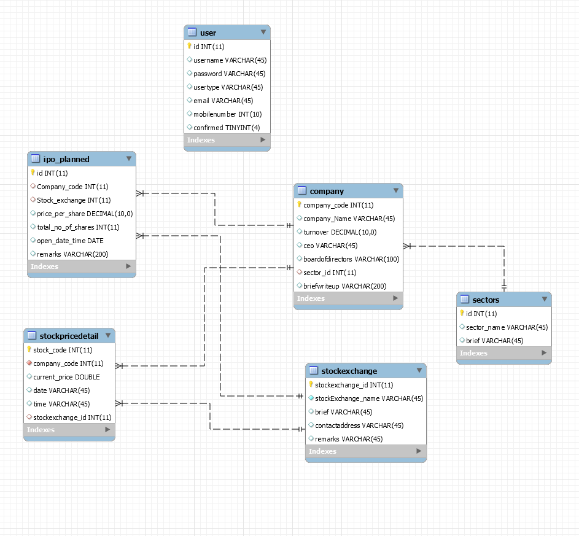

**Stock Market Charting - UI Screenshots**

1. Login Page

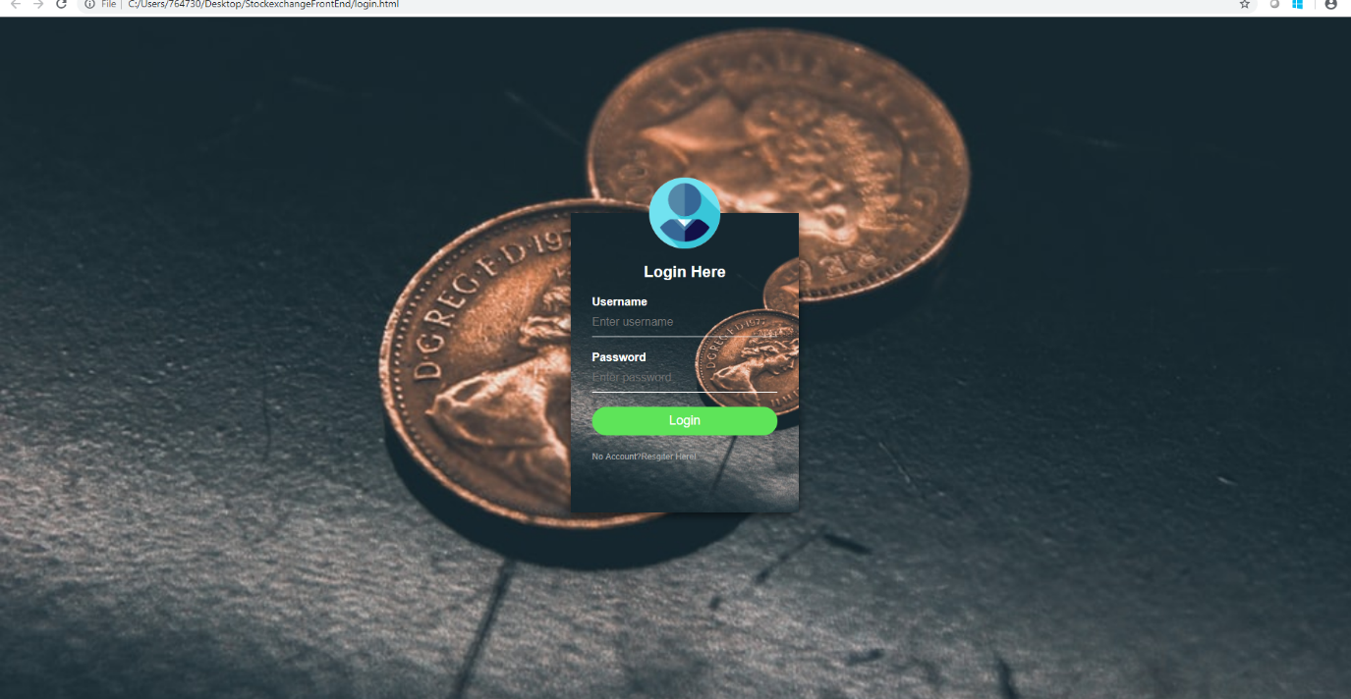

1. Admin-Landing page

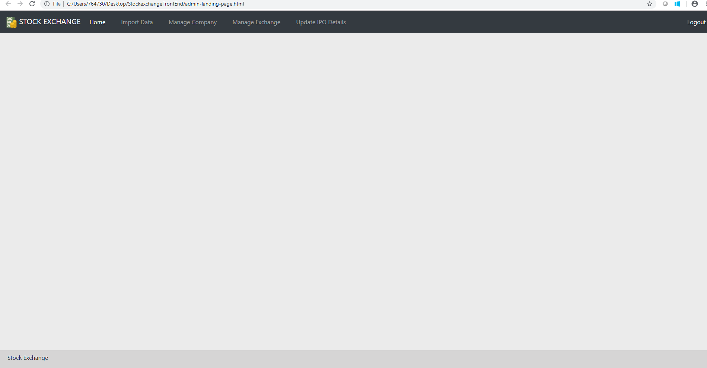

1. Admin-Manage Company

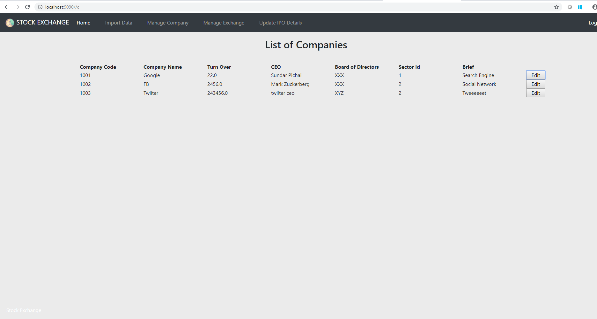

1. Admin-import data

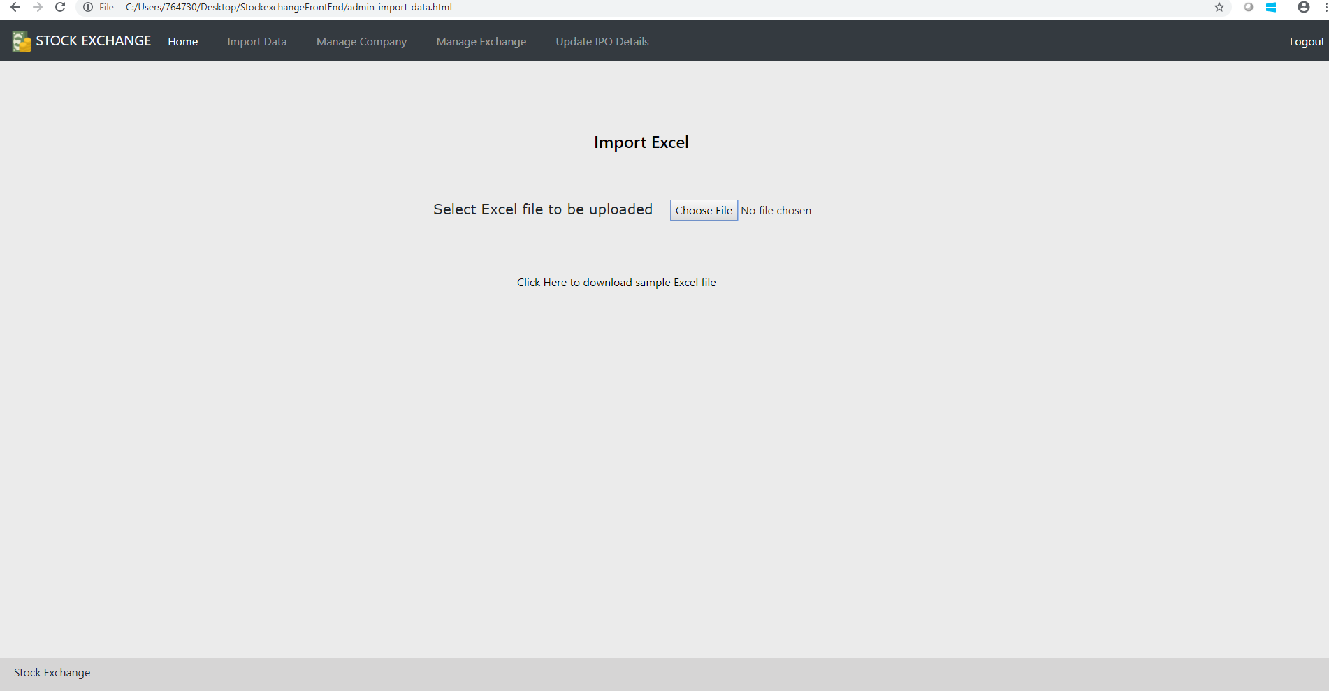

1. Admin- create company

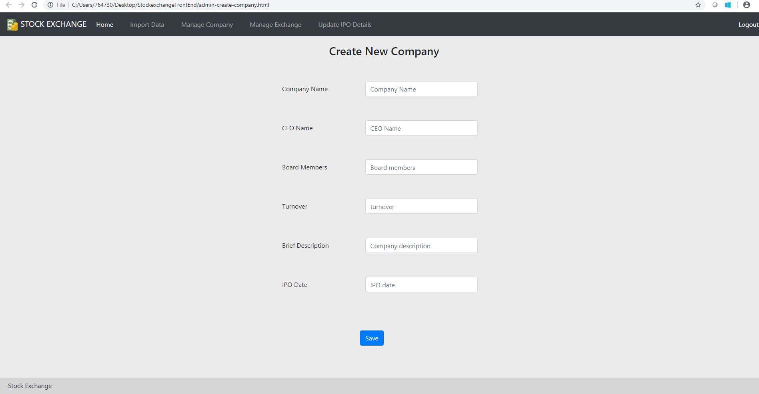

1. User-landing page

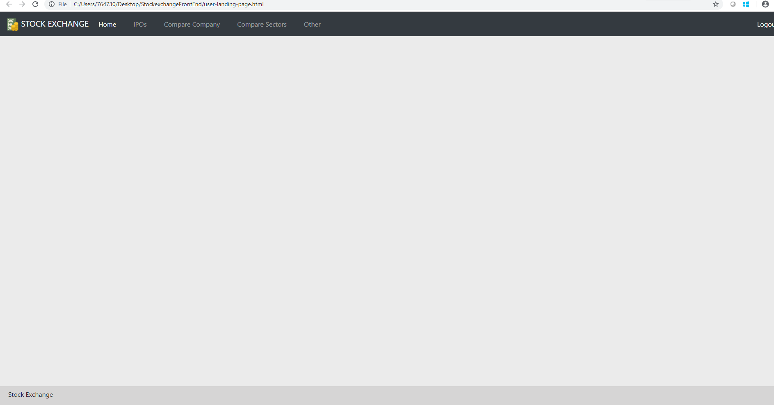

1. User Compare company

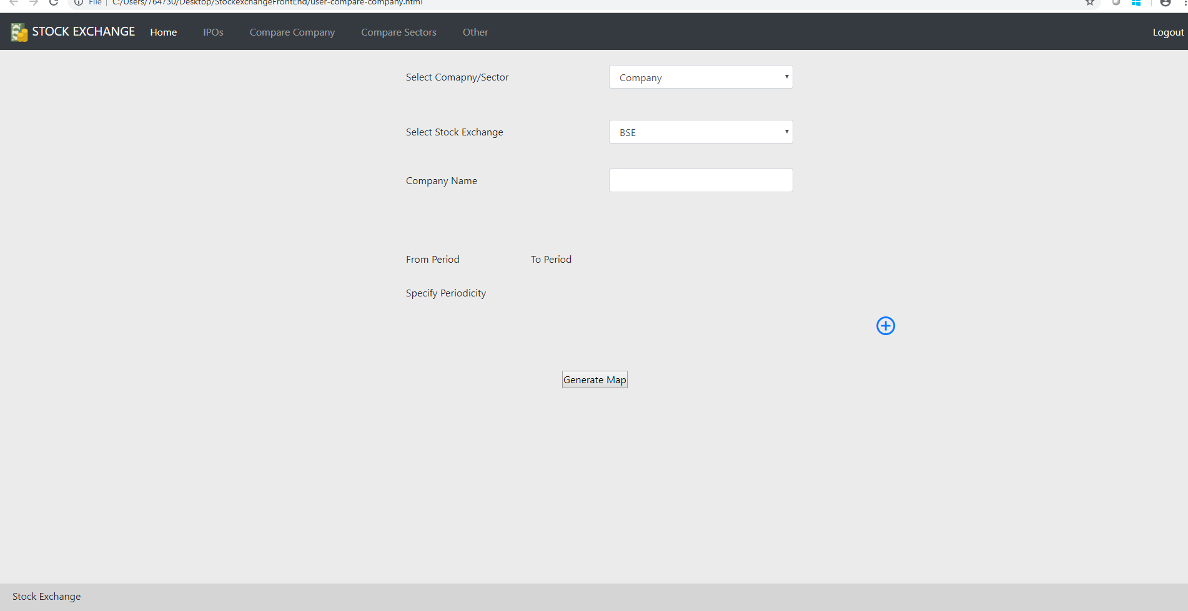

**GitHub Link:**

<https://github.com/sudharshana12/StockExchange-Milestone-1>